New Hampshire State Legislation: Resource Guide
To track bills, search for your Representative/Senator and see who sits on key committees go to the General Court homepage.
www.gencourt.state.nh.us.
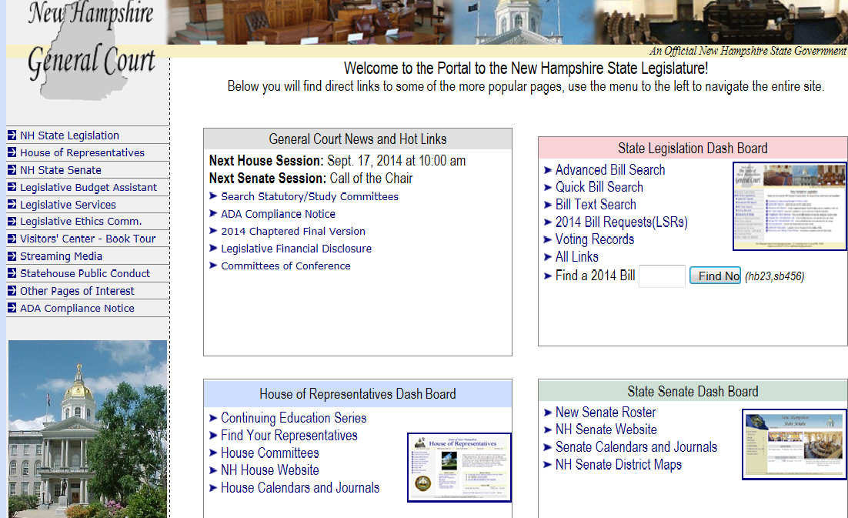
To search for a current bill, Insert bill number here. Ex. HB1410, SB407 (See p.2 for further details.)
To see who serves on key committees, click here. Then click on “standing committees” on the left. Click on the committee name (ex. Environment & Ag or Judiciary)
To lookup your Senator, click here. Then click on the “members” tab on the left. Then “Who’s my Senator?”
To find your Representative(s), click here. Then choose your town and click “Go”.

Understanding where a bill is at in the process (Part 1):
- After entering “HB1410” into the Gencourt homepage (see p.1), it brings us to this screen. You can see that this bill was signed into law by the Governor after passing both the House of Representatives & the Senate.

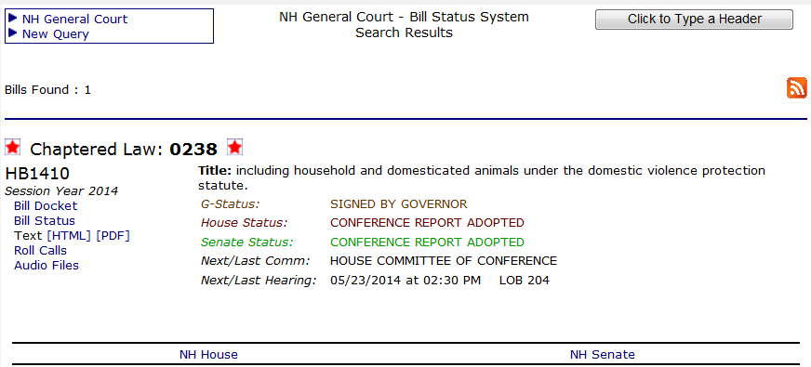
To see the bill language (how it alters existing law or creates a new law), click here.
To see the process of how this bill became law, click here. During the legislative session, this link will show you where the bill is at in the process.

Understanding where a bill is at in the process (Part 2):
- After clicking on “bill docket”, you can see on the next page the process this bill took to become law. This screen is updated after every vote so is up to date during the legislative session.
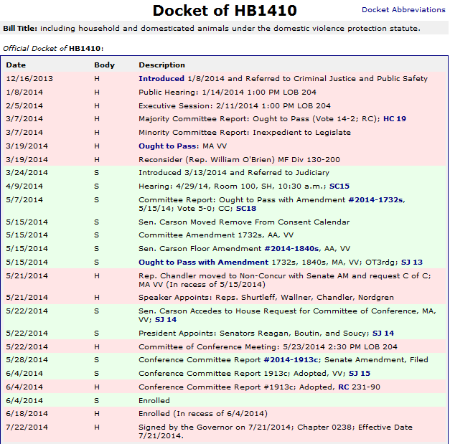
Governor signs the bill into law on July 21st and it is effective immediately! Animals are now protected under the domestic violence statute!
A “conference committee” is created with four Reps and three Senators to find a compromise. Compromise is reached and the bill is enrolled to check for legal/clerical errors.
Committee votes 5-0 “Ought to Pass”, however, an amendment is added when it reaches the Senate floor so must be approved by House again.
Assigned to Senate Judiciary committee. Public hearing in front of committee with date, time and location detals. (SH = State House)
Full House voted (400 members). 130 voted Inexpedient to Legislate, 200 voted Ought to Pass. Passes full House and moves to Senate.
Introduced and assigned to the House Criminal Justice & Public Safety committee
Public hearing in front of committee members with date, time and location. (LOB = Legislative Office Building Rm. 204)
Executive Session (committee votes on bill, no public comments) with date, time & location.
Vote results: 14-2 to pass bill (“Ought to Pass”). Two members voted “Inexpedient to Legislate” which is a vote not to pass the bill. Bill moves on to full House.
Brief summary of bill
Bill number (in this case, House Bill 1410 indicating it started in the House)

